Default Main Screen
When you first instantiate a DMX module on your site you will see a screen similar to the one below (albeit without content yet). In this chapter we will look at the various elements of this screen and what they do.
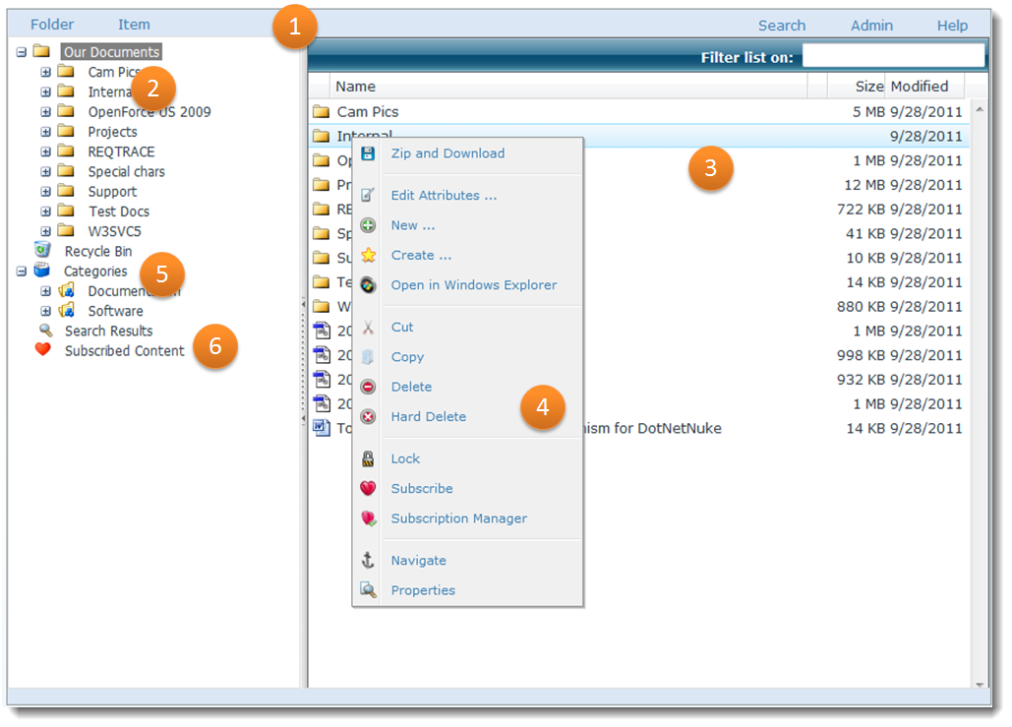

The menu system
Document Exchange uses its own menu system to control the contents. You‘ll find there two menus: a fixed menu bar at the top of the screen (1) and a context menu (4) that can appear on both the file list (3) and the folder tree (2). At all times the menu reflects actions that are permitted on the current selection. So, for instance, if you have no items selected in the file list, the item menu will not show up. If something is locked, the ‘lock’ menu command will not show up. This means that whenever you change your selection, your browser talks to the server to retrieve what elements to display and adjusts the menu. The only thing you might notice of this process is that there could be a small time lag between selecting something and the menu changing to adjust to the new selection.
We will now look a little more closely at the menu headings. Note that this part is subject to change. The main headings are ‘Folder’, ‘Item’, ‘Selection’, ‘Search’, ‘Admin’, and ‘Help’. The Folder menu operates on what is selected in the tree view (2). It contains important actions such as ‘New …’ for adding content. Note that this menu is not concerned with any folder being selected on the right.
Next is ‘Item’. The Item menu is shown if only one item (File, Folder, or Hyperlink) is selected on the right. The menu operates just on this single item and includes the ‘new version’, ‘edit’, and ‘download’ buttons for instance. As said before it is aware of context and will change the menu options displayed in correspondence to the item being selected.
The ‘Selection’ menu is shown instead of the ‘Item’ menu in case multiple items are selected. In this case you may opt to zip & download, or ‘add to selection’ for instance.
If there are items on the clipboard, then the ‘Clipboard’ menu is shown. This menu is used for operations on the items on the clipboard.
The ‘Admin’ menu is only available for Administrators and gives access to all administration screens of DMX.
The ‘Help’ menu is for accessing help.

Context menu
Whenever you right click on an item in the item list (3) or folder tree (2), you will see a pop-up menu appear. This is a subset of the menu that you see in the menu bar. It operates on the selection.

The Treeview (2-5-6)
A ‘treeview’ is a technical term for an area on screen showing a hierarchical tree of items with optionally lines and plus/minus icons. Typically computer users recognize these from the file explorers to navigate files and folders on the hard disk. In the case of Document Exchange this is no different. The treeview in Document Exchange contains ‘nodes’ for several aspects of the document management system, and is extensible through programming. The first and foremost function of course, is to show and allow the user to navigate the folder structure.
The folder structure displayed (2) starts at the folder specified by the admin as root folder under the module settings:
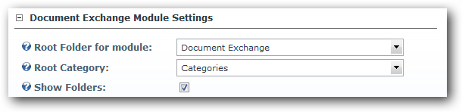
Underneath the Folders we see the Categories (5) if there are any defined. Categories, like folders, also have a hierarchical structure.
Finally we can see containers for ‘Search Results’ (displaying last search results), ‘My Unapproved Items’ (items that you uploaded but were not yet approved, ‘Non Approved items’ (items that you should decide to approve or not), and ‘Subscribed Content’ (showing all the items you subscribed to).

The Item List (3)
The item list shows all the items underneath the node selected on the treeview. You can search the contents with lightning speed now by typing in what you’re looking for in the ‘quick search box’ at the top. The list is immediately filtered on that string. Use the context menu to operate on the content. Selecting an item will cause the details screen to reload.

